AEPA #21-G Security Solutions
EXTENSION OF AGREEMENT made by and between Deledao (Vendor) and

Carolinas Alliance 4 Innovation dba Carolina BUY (Member)
AEPA has approved the extension of this Agreement. The Member and Vendor hereby agree to extend the Agreement for an additional contract term, which will begin immediately upon the expiration of the previous contract term. Upon the execution from authorized officers of the Member and the Vendor, this Agreement is hereby extended. This extension shall be subject to the same Terms and Conditions as contained in the original AEPA solicitation, and subject to the Bylaws, Policies and Procedures of AEPA in addition to the Member Terms and Conditions.
[X Contract Term: March l, 2024, through February 28, 2025
The Vendor hereby agrees to provide complete information of any deleted and new products or prices as allowed under headings (Product Addition/Discontinuation) and (New Catalogs/Price Changes) of the AEPA solicitation.
Member Carolinas Alliance 4 Innovation dba Carolina BUY
Authorized Signature
Typed Name G Fred Payne Date 12/10/2023
Vendor
Authorized Signature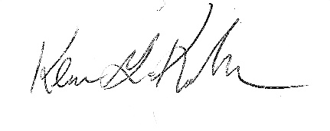Title: Vice President, Business Development
Typed Name: Kevin Kuckkan Date: 12/20/2023
Discontinue: We, the Vendor, desire to discontinue the contract.
Authorized SignatureTitle Typed NameDate

